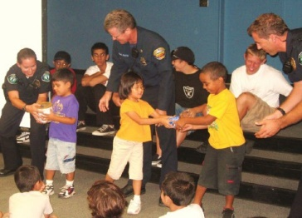
The Team Kids Challenge is coming to Oakridge!
What is Team Kids?
The Team Kids Challenge is a five week program that brings community role models such as police officers, fire fighters, and veterans to our school and inspires students to engage in community service. Students take action to improve community issues such as animal shelters, feeding the hungry, helping the homeless, and the environment. 100% of all items collected and funds raised by students go directly to community-based nonprofit organizations.
For more information to go: http://www.teamkids.org/
Who is running Team Kids?
Kick-off Assembly: Team Kids staff, police officers, and fire fighters lead the kick-off assembly to outline the program, demonstrate teamwork, and deliver the critical message that students are powerful resources for change in our world. The students are presented with three community issues and are given three weekly challenges to collect a certain amount of funds or resources surrounding each issue.
Three Weekly Challenges: 5th grade students, Team Kids staff, and parent volunteers organize three one week-long donation drives for three local charities.
Carnival: 5th grade students with the help of Team Kids staff and parent volunteers create and facilitate game booths for the school during recess. All students can participate and 100% of the funds raised through additional ticket sales are donated to a non-profit organization selected by 5th grade students.
When will this happen?
The schedule of events includes:
Team Kids will kick off with an assembly on:
October 10th, 2017 Carnival: November 3rd, 2017
Grades | Time | Location
K-2 | 2:15-2:45pm | Gym
3-5 | 3:00-3:30pm | Gym
Grades | Time | Location
5th Grade | K-5 – Recess 10:15-12:45 | Gym

5th Grade Students Leadership Meetings: 5th Grade Students debrief meeting.
Date | Time | Location
November 8th | 12:05-12:55pm | Gym
Date | Time | Location
October 11th | 12:05-12:55pm | Gym
October 18th | 12:05-12:55pm | Gym
October 25th | 12:05-12:55pm | Gym
November 1st | 12:05-12:55pm | Gym

