La Hora VIP
Race your partner to the finish line by correctly stating the time of the box on which you land. If an incorrect answer is given, the player must move to his/her previous position on the board. If a player lands on the same space of another player, add 1 hour to the time on the space. This will be the new time that the player must stay to maintain his/her position on the board.

If you roll: 1,2=move 1 spaces 3,4=move 2 spaces 5,6=move 3 spaces

Start
5:00
10:00
3:00
Move back 1 space
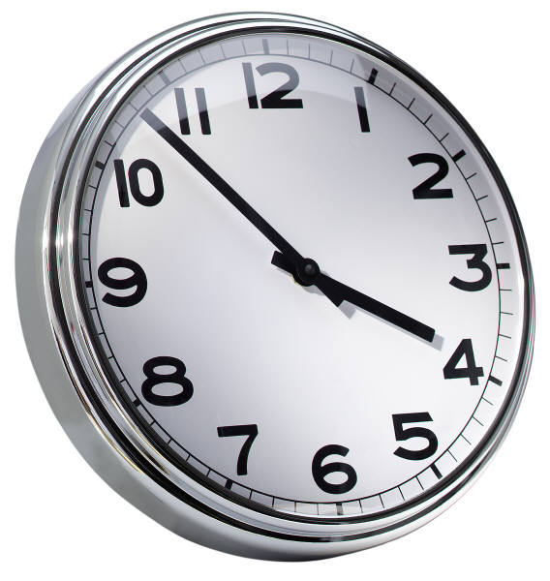
¡Fiesta! La Sala de VIP
1:30
3:30
Move back 3 spaces
12:22
6:30
4:14
9:17
10:27
1:15
Move back 2 spaces
1:00
7:11
11:25
8:08
4:10
2:05

