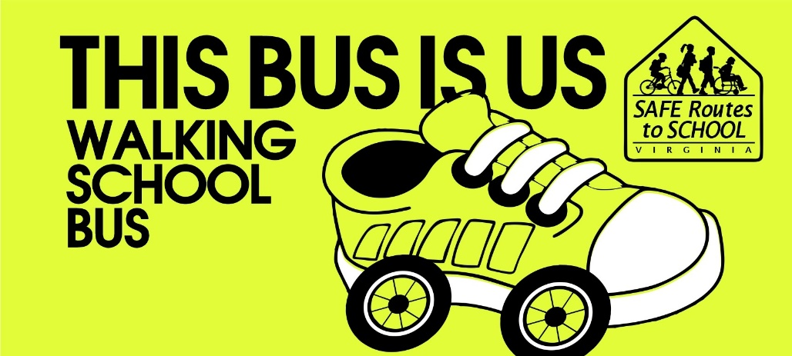

THE OAKRIDGE WALKING SCHOOL BUS
“US BUS” PILOT
INTEREST FORM QUESTIONS
Please answer the following questions for route planning and AM scheduling and submit to
APS Safe Routes to School Coordinator lauren.hassel@apsva.us

What’s your name? ________________________________________________________________

What’s your email address? (needed to set up Walking School Bus).
___________________________________________________________________

What's the name of the civic association where you live?

____________________________________________________________________

Please indicate the number of students from your household who will be traveling to school:

___________

What is the age and grade of your student/s?

______________________________________________

Route Planning
Bus Eligibility and Walk Zone Maps for every school are posted on the APS website
--Use the link below to find the map for OAKRIDGE
Bus Eligibility Zone Maps
https://www.apsva.us/transportation-services/bus-eligbility-zones/
COVID ‘21 Reopening Expanded Walk Zone Maps for affected schools (not Oakridge)
https://www.apsva.us/transportation-services/sy-2020-21-expanded-walk-zones/

What intersection is closest to your home? List names of cross streets. (e.g. N Main St and N 12th Road)
No need to provide your actual address

____________________________________________________________________________________

____________________________________________________________________________________

Which streets would you take to walk to school? List street names.

_____________________________________________________________________________________

____________________________________________________________________________________

Scheduling

What days of the week would you be interested in joining the Walking School Bus?
Check all that apply. NOTE: The pilot will be doing MORNING/DROP-OFF only.

- Monday
- Tuesday

- Wednesday

- Thursday

- Friday

Are you interested in helping to lead the Walking School Bus?

- Yes
- No

What days of the week could you help? Check all that apply.

- Monday
- Tuesday
- Wednesday
- Thursday
- Friday
______________________________________________________
PLEASE SUBMIT YOUR RESPONSES TO:
APS Safe Routes to School Coordinator
lauren.hassel@apsva.us
